PRÁCTICA #3
Problem A: Not So Mobile
Input file: mobile.in

Before being an ubiquous communications gadget, a mobile was just a structure made of strings and wires suspending colourfull things. This kind of mobile is usually found hanging over cradles of small babies.
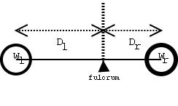
The figure illustrates a simple mobile. It is just a wire, suspended by a string, with an object on each side. It can also be seen as a kind of lever with the fulcrum on the point where the string ties the wire. From the lever principle we know that to balance a simple mobile the product of the weight of the objects by their distance to the fulcrum must be equal. That is W_{l}×D_{l} = W_{r}×D_{r} where D_{l} is the left distance, D_{r} is the right distance, W_{l} is the left weight and W_{r} is the right weight.
In a more complex mobile the object may be replaced by a sub-mobile, as shown in the next figure. In this case it is not so straightforward to check if the mobile is balanced so we need you to write a program that, given a description of a mobile as input, checks whether the mobile is in equilibrium or not.

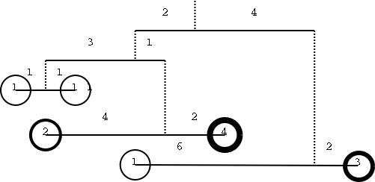

Input

The input begins with a single positive integer on a line by itself indicating the number of the cases following, each of them as described below. This line is followed by a blank line, and there is also a blank line between two consecutive inputs.

The input is composed of several lines, each containing 4 integers separated by a single space. The 4 integers represent the distances of each object to the fulcrum and their weights, in the format: W_{l} D_{l} W_{r} D_{r}

If W_{l} or W_{r} is zero then there is a sub-mobile hanging from that end and the following lines define the the sub-mobile. In this case we compute the weight of the sub-mobile as the sum of weights of all its objects, disregarding the weight of the wires and strings. If both W_{l} and W_{r} are zero then the following lines define two sub-mobiles: first the left then the right one.

Output
For each test case, the output must follow the description below. The outputs of two consecutive cases will be separated by a blank line.
Write `YES' if the mobile is in equilibrium, write `NO' otherwise.

Sample Input
1

0 2 0 4
0 3 0 1
1 1 1 1
2 4 4 2
1 6 3 2

Sample Output
YES
Problem B: Crypt Kicker II
Input file: crypt.in

A popular but insecure method of encrypting text is to permute the letters of the alphabet. That is, in the text, each letter of the alphabet is consistently replaced by some other letter. To ensure that the encryption is reversible, no two letters are replaced by the same letter. A powerful method of cryptanalysis is the known plain text attack. In a known plain text attack, the cryptanalyst manages to have a known phrase or sentence encrypted by the enemy, and by observing the encrypted text then deduces the method of encoding. Your task is to decrypt several encrypted lines of text, assuming that each line uses the same set of replacements, and that one of the lines of input is the encrypted form of the plain text the quick brown fox jumps over the lazy dog.

Input
The input begins with a single positive integer on a line by itself indicating the number of test cases, followed by a blank line. There will also be a blank line between each two consecutive cases. Each case consists of several lines of input, encrypted as described above. The encrypted lines contain only lowercase letters and spaces and do not exceed 80 characters in length. There are at most 100 input lines.

Output
For each test case, decrypt each line and print it to standard output. If there is more than one possible decryption, any one will do. If decryption is impossible, output:
No solution.
The output of each two consecutive cases must be separated by a blank line.

Sample Input
1
vtz ud xnm xugm itr pyy jttk gmv xt otgm xt xnm puk ti xnm fprxq
xnm ceuob lrtzv ita hegfd tsmr xnm ypwq ktj
frtjrpgguvj otvxmdxd prm iev prmvx xnmq

Sample Output
now is the time for all good men to come to the aid of the party
the quick brown fox jumps over the lazy dog
programming contests are fun arent they
Problem C: Doublets
Input file: doublets.in

A doublet is a pair of words that differ in exactly one letter; for example, “booster” and “rooster” or “rooster” and “roaster” or “roaster” and “roasted”. You are given a dictionary of up to 25,143 lowercase words, not exceeding 16 letters each. You are then given a number of pairs of words. For each pair of words, find the shortest sequence of words that begins with the first word and ends with the second, such that each pair of adjacent words is a doublet. For example, if you were given the input pair “booster” and “roasted”, a possible solution would be (“booster,” “rooster,” “roaster,” “roasted”), provided that these words are all in the dictionary.

Input
The input file contains the dictionary followed by a number of word pairs. The dictionary consists of a number of words, one per line, and is terminated by an empty line. The airs of input words follow; each pair of words occurs on a line separated by a space.

Output
For each input pair, print a set of lines starting with the first word and ending with the last. Each pair of adjacent lines must be a doublet. If there are several minimal solutions, any one will do. If there is no solution, print a line: “No solution.” Leave a blank line between cases.

Sample Input
booster
rooster
roaster
coasted
roasted
coastal
postal

booster roasted
coastal postal

Sample Output
booster
rooster
roaster
roasted

No solution.

